**Hypothesis testing**: It’s very confusing, so we’ll try to understand using a coin toss example.

**Testing**: For a coin, we have to determine if the coin is biased towards head or not.

Let’s understand what does biased toward head means:

If the probability of getting head in a coin toss is greater than 0.5, then it’s biased towards head, otherwise it’s not biased toward head.

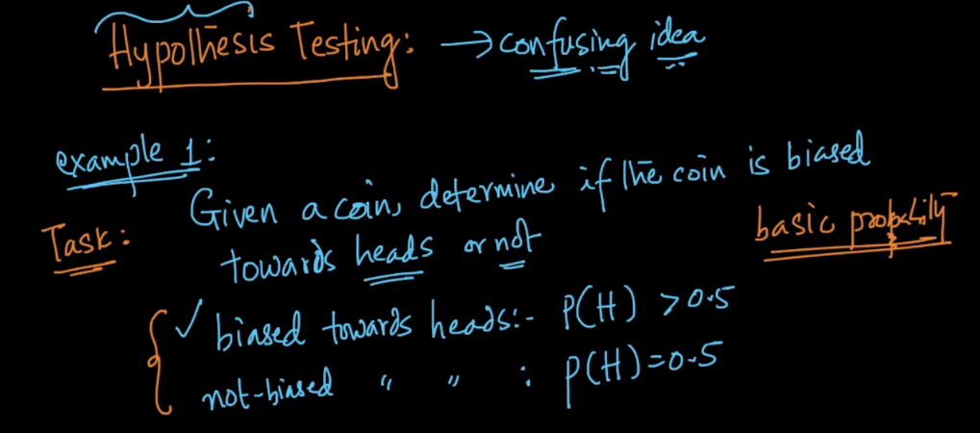

Following steps we need to perform for hypothesis testing:

1 ) **Design Experiment:**

So first we design experiment as we flip a coin 5 times and counts the no. of heads we get in these 5 flips, and this count is called **Test-Statistic.**

2 ) **Perform experiment:**

Since we are taking coin is biased towards head, soin all the 5 flips we get head. Therefore Test-Statistic is 5, let’s say Test-Statistic as X, therefore X = 5.

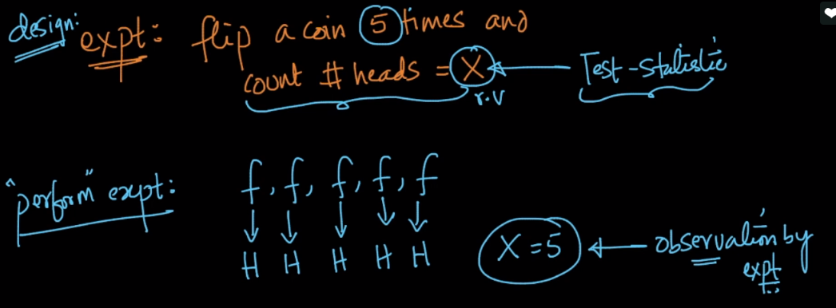

3 ) **Find Probability of occuring observation/Test-statistic, while given an assumption or null hypothesis.**

For current example observation is 5, and **null hypothesis** will be Coin is not biased towards head.

So we have to find the probability of getting 5 heads in 5 flips when coin is not biased towards head.

Since for each flip of unbiased coin, prob of getting head is ½, therfore for 5 flips prob will 1 / 25

P(X=5 | coin is not biased toward head) = 1/32 = 0.03 or 3%;

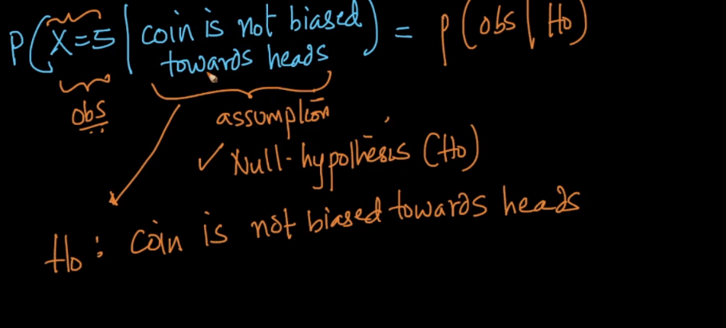

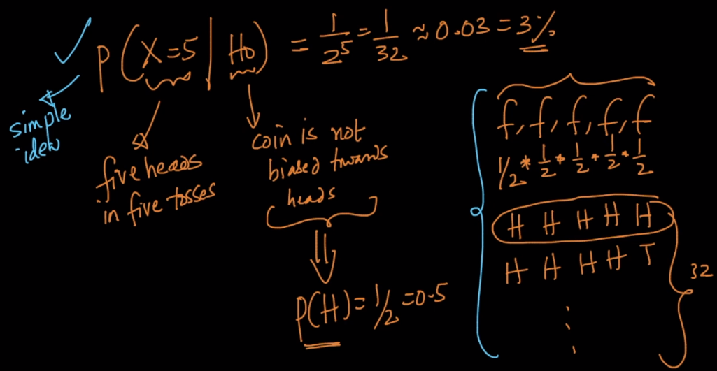

4 ) **Check the probability or p-value to determine whether to accept null hypothesis or not**.

Note: we will accept null hypothesis only if p-value >= 5 or reject null hypothesis if p-value < 5.

Since in current ex: P(x | H0) = 3, which is smaller than 5, therefore we reject the null hypothesis which says coin is not biased towards head, therefore we now can accept that coin is biased towards head.

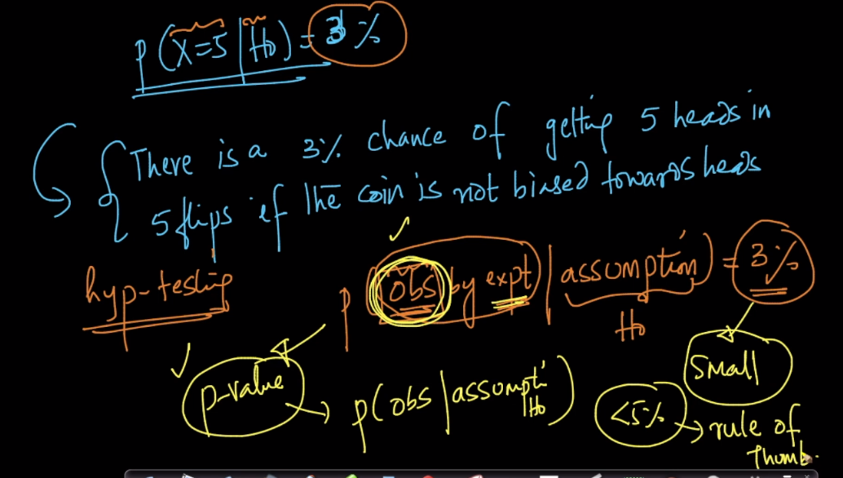

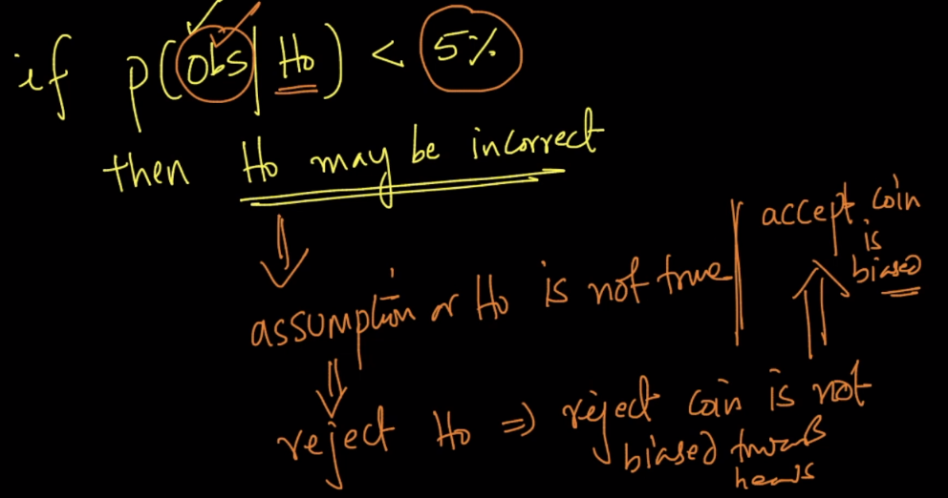

**Note:** we need be extremely careful while performing our experiment, that means how many times we are performing experiment.

For example if in our current example we are flipping coin 5 times, if we flip it 3 times or 10 times then results might be different.

Let’s say we flip coin 3 times, then

P(X = 3 | coin is not biased towards head) = 1 / 23 = 1/8 = 12.5 %

Since P > 5, so here we are accepting the null hypothesis that coin is not biased toward head, which is completely different from result we obtained while flipping 5 times.

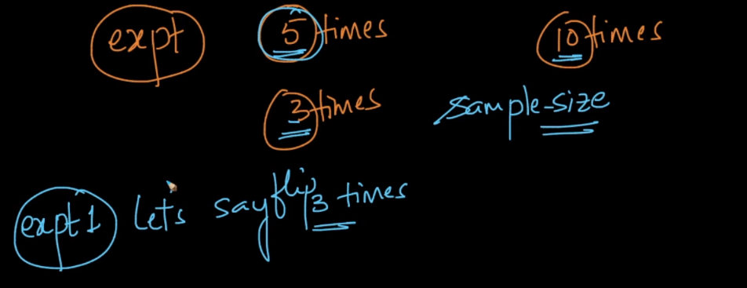

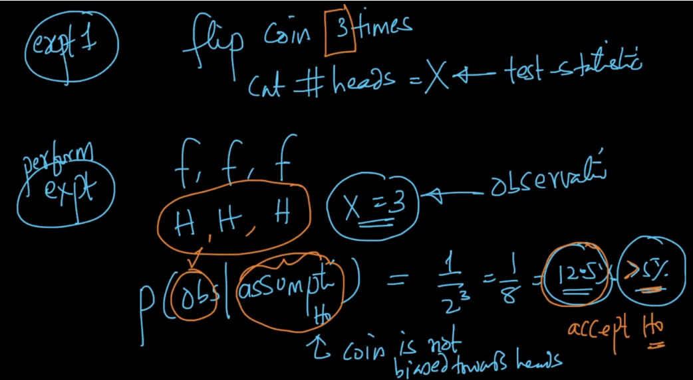

**Following things one should keep in mind while performing hypothesis testing:**

1. Design of the experiment (carefully choose how many times we will perform experiment as it change the result entirely)
2. Carefully choose Null hypothesis ie H0
3. Calculating P(obs | H0) should be easy & feasible.

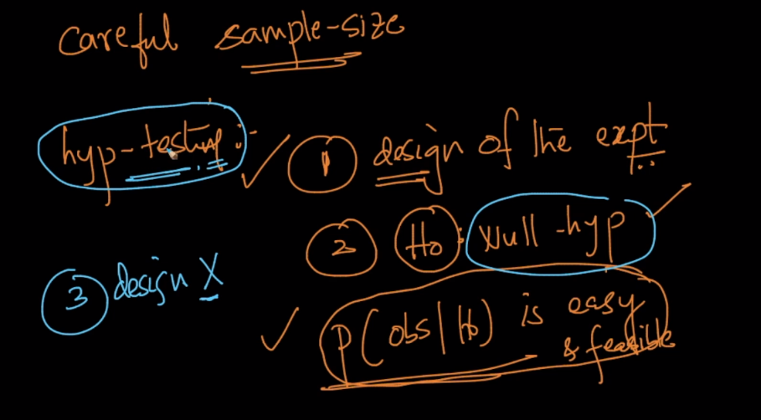

**Another Example:**

Armature Example: CSK winning 13 games in a row.  
1.P(X>=13/Ho=Games not played in their home ground )=1/2^13=.01% which is least probable,hence Ho is to be discarded and alternative H1=All games played in their Home ground may be considered.

2.if P(X>=5/Ho=Games not played in their Home ground)=1/2^5=3% which is less than 5% hence Ho to be discarded and H1=All games played in their home ground may be considered.

3.If P(X>=3/Ho=Games not played in their home ground )=1/2^3=12.5% which is greater than 5% hence we can assume that the null hypothesis holds good.We can infer that even if they had not played in their home ground there is a high chance of them winning all the three games.